Create nonprod network DRG with ORM Stack

Contents

1. Introduction 3
2. Workflow diagram to deploy the stack 3
3. Create stack for the nonprod network DRG on “Default Domain” 4
4. Plan the Job 6
5. Apply the Job 7
6. Verify in the Console 9
7. Destroy the stack 10

Introduction

This resource provides the Drg resource in Oracle Cloud Infrastructure Core service. DRG stands for "Dynamic Routing Gateway," and OCI stands for "Oracle Cloud Infrastructure." In OCI, a DRG is a virtual router that provides a private network connection between your VCN (Virtual Cloud Network) and an external network. With DRG in OCI, you can establish a secure, private network connection between your VCN and other OCI resources or external networks such as an on-premise data center, another cloud provider, or a partner network. DRG to connect multiple VCNs within the same region or across regions, which allows you to create a hub-and-spoke network topology. This topology is useful for creating centralized services or applications that need to be accessed from multiple VCNs.

Workflow diagram to deploy the stack

Below diagram shows how the Terraform Artifact are applied in the OCI. While creating a ORM stack, using terraform deliverables Init, Plan and Apply is the flow to provision the resource in the OCI. We can have the deliverables in any of below.
- GitLab/GitHub Repo
- Bitbucket
- Can be in folder/.zip in the local disk
- Object Storage Bucket
- Can be in compartment
- Oracle provided Template


Create stack for the nonprod network DRG on “Default Domain”

Go to OCI Console Developer Services Resource Manager Stacks select the compartment Create Stack

My Configuration Folder Browse Select the “nonprod network drg” folder that contains the terraform Upload

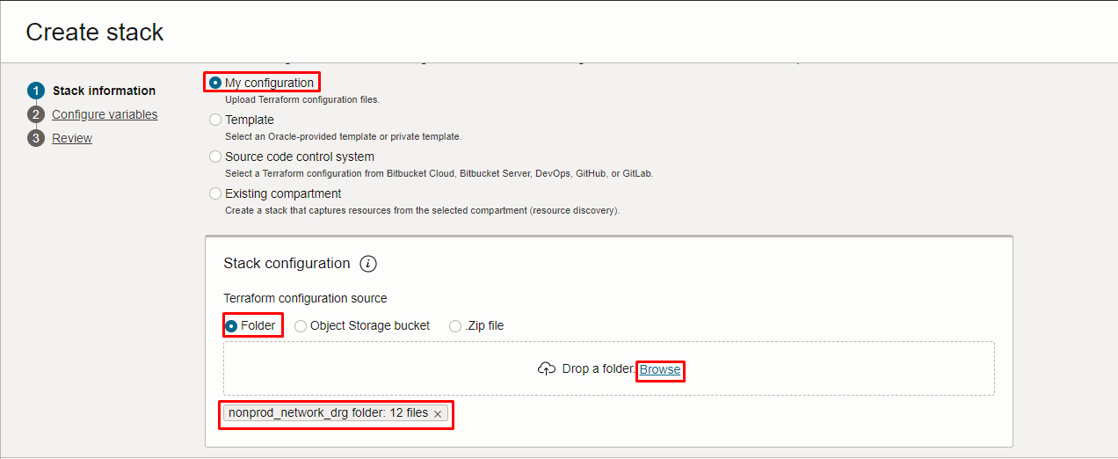
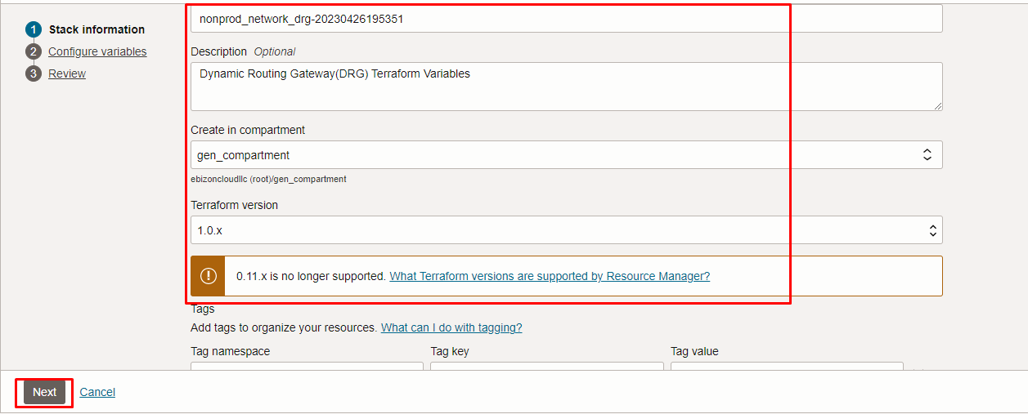

Click “NEXT”

Select the parameters as per the below screen,
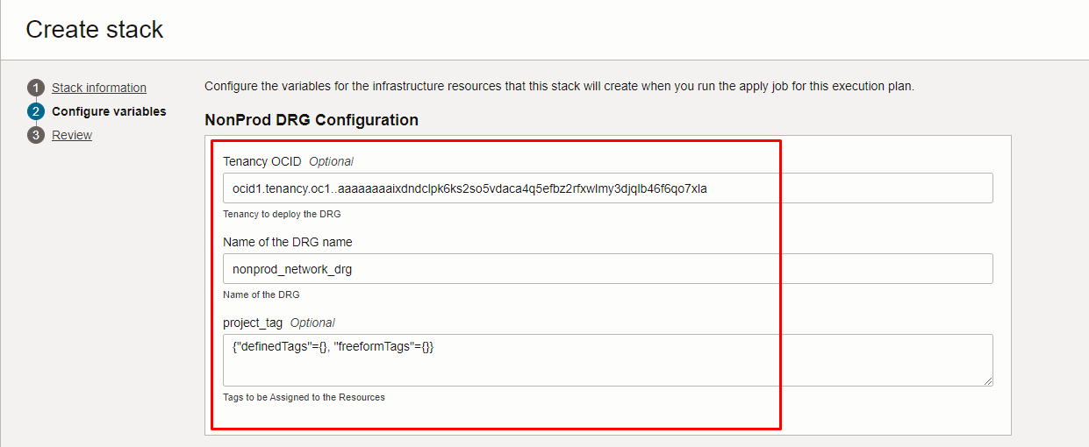

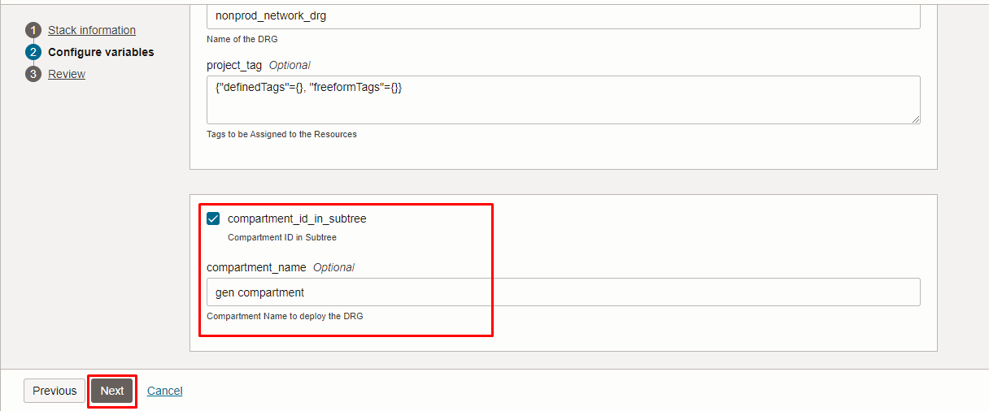
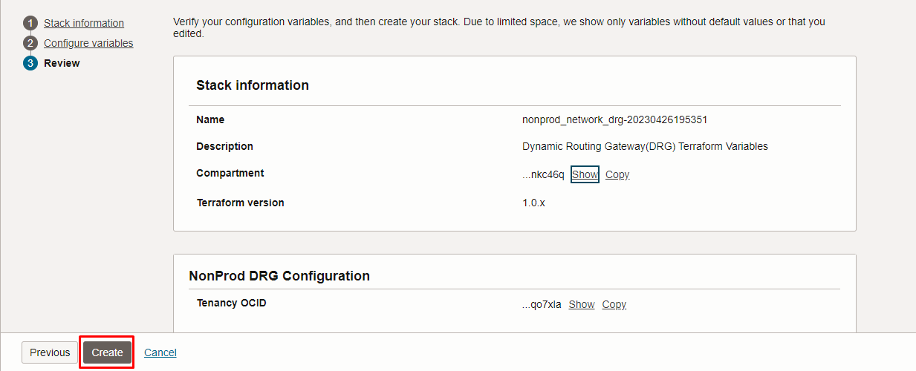

Click “NEXT” Click “CREATE”

Plan the Job

Click the “Plan”

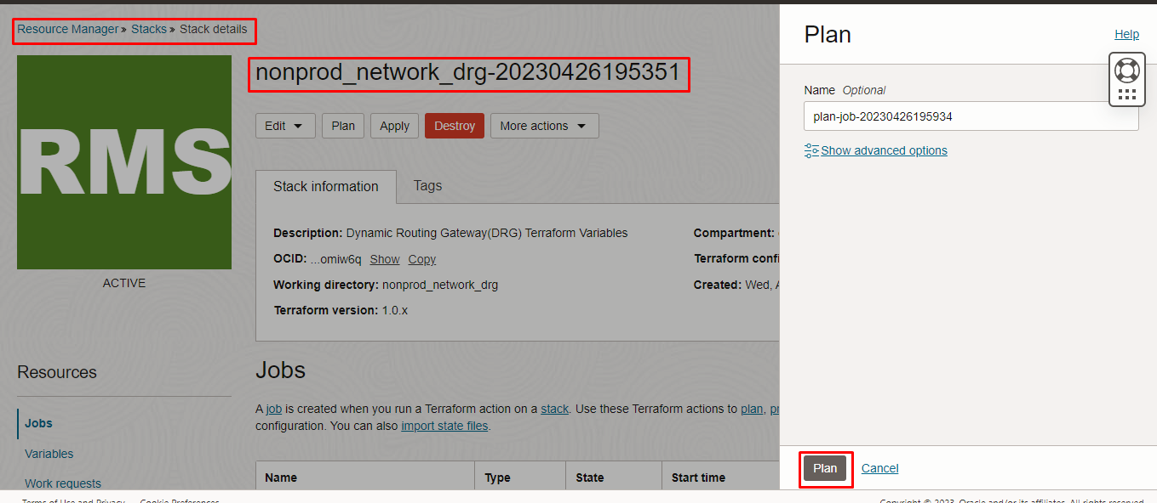

Verify the Plan is successful.

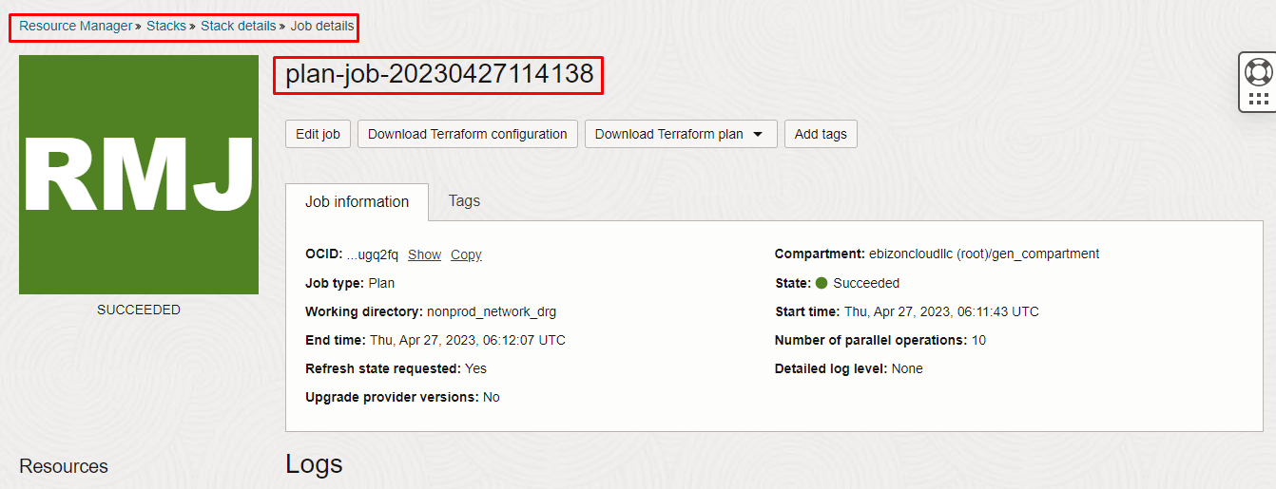

Apply the Job

Once the “plan” is success, now click “Apply”

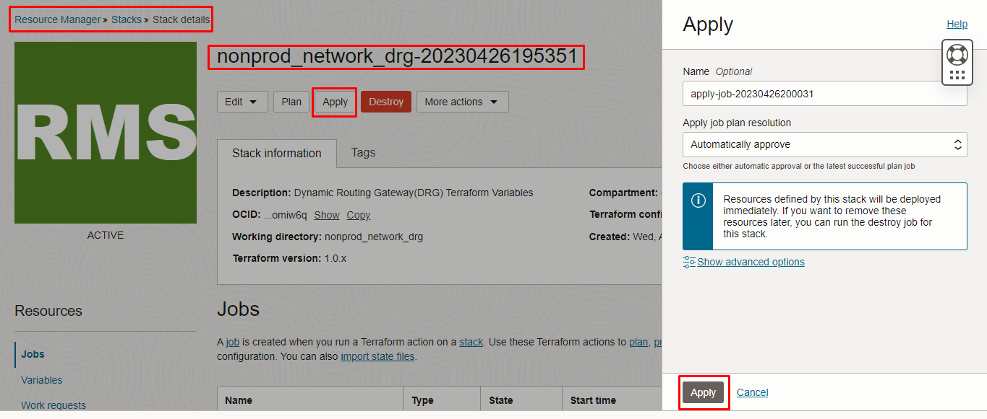

Verify the Apply is successful.

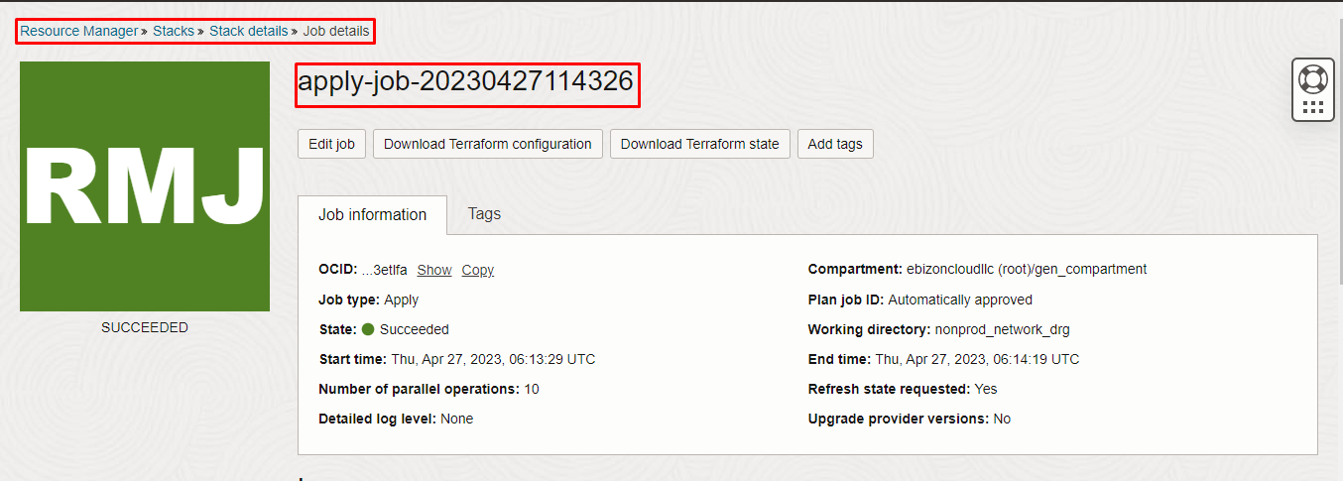

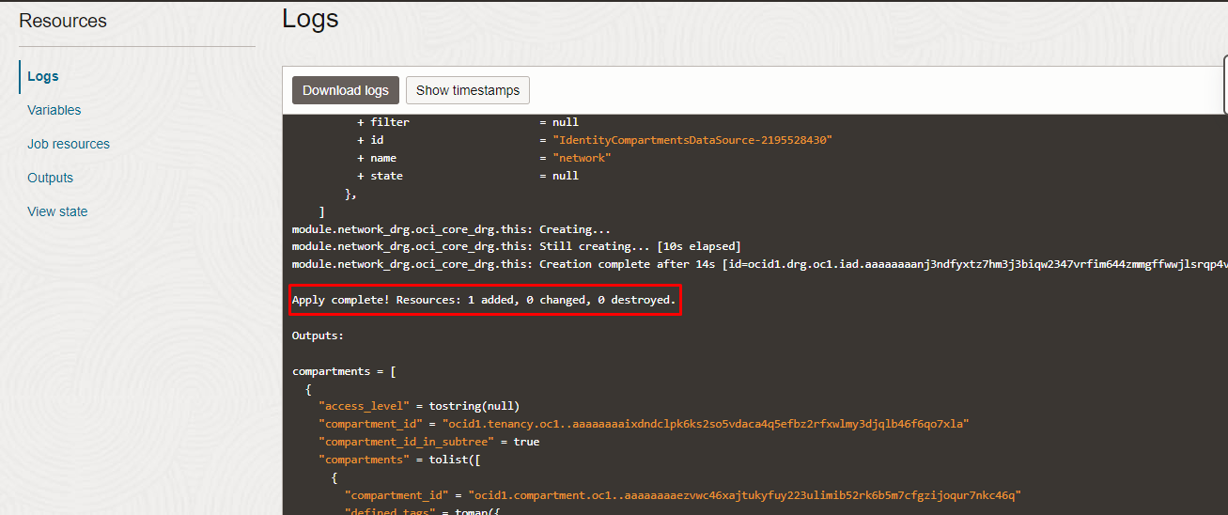

Verify in the Console

Go to OCI Console Networking DRG

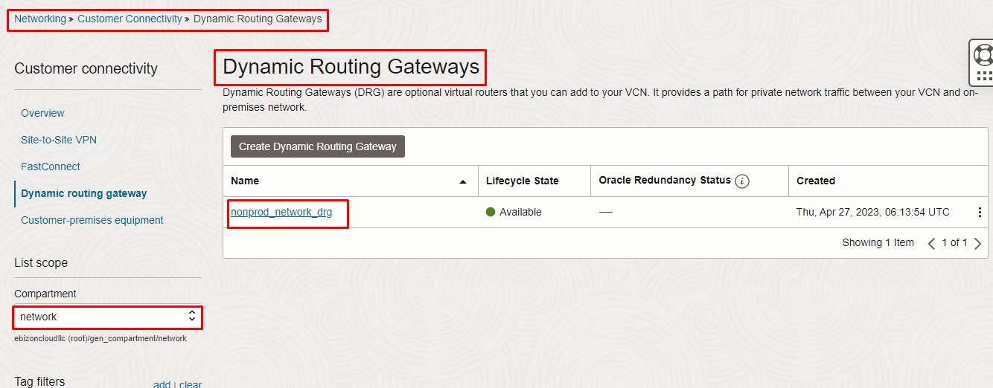
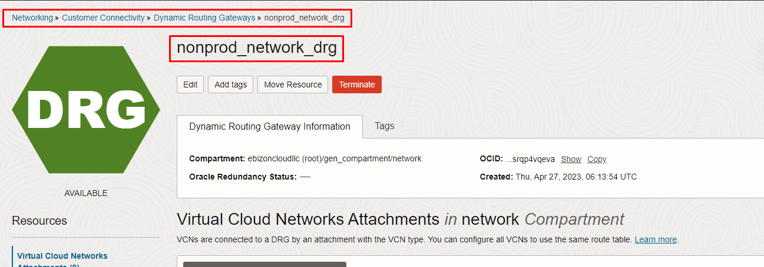

Destroy the stack

Create a destroy job in Resource Manager to release resources associated with a stack and clean up the tenancy. Once destroyed data cannot be recovered from resources.

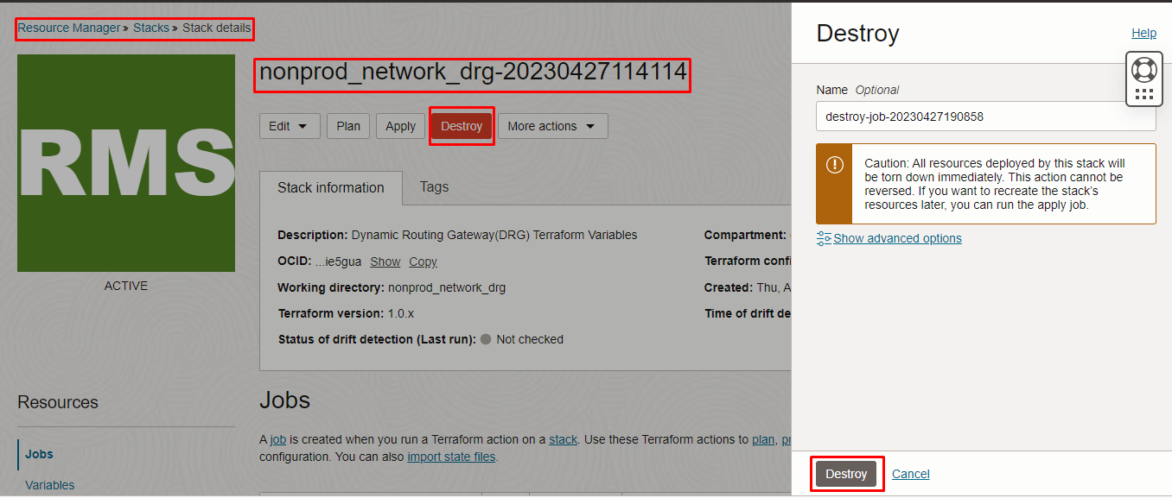

# END #

